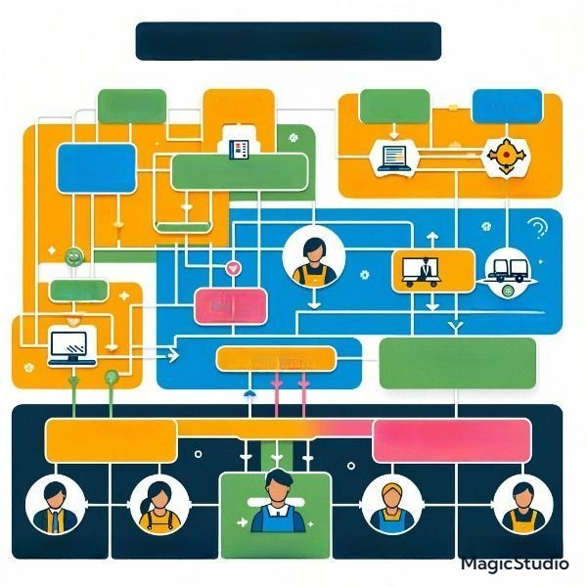

Farmer Support

Transactions

Financial Transactions

**Technics Support Team**

**Login Support Team**

Farmer Support

**Logistic Support**

**Team**

**Login Support**

**Team**

**Coordination**

**Team**

**Technic Support**

**Buyer**

**Support**

Support

**Administration**

**Farmer team**

Team

Support

Buyer

Farmer

Farmer

Organizational Map